**Assignment 4: Heap Data Structures: Implementation, Analysis, and Applications**

**Introduction**

For effective sorting and management of priority queues, computer scientists often turn to heap data structures. Here we take a look at Heapsort, a sorting algorithm that relies on comparisons, and see how it performs in different situations. In addition, we discuss the design and implementation of a binary heap priority queue and examine its practical uses, such as task scheduling. Priority queue system design decisions and essential actions are detailed in this study after an examination of Heapsort's implementation, analysis, and comparison.

**Heapsort Implementation and Analysis**

**Heapsort Implementation**

Using a binary heap, the Heapsort algorithm sorts data based on comparisons. If every node in a binary tree has the heap attribute, then the tree is called a binary heap. Two main steps make up the algorithm:

* Build a max-heap from the unsorted input array.
* Extract the maximum element from the heap repeatedly, placing it at the end of the array, while maintaining the heap property.

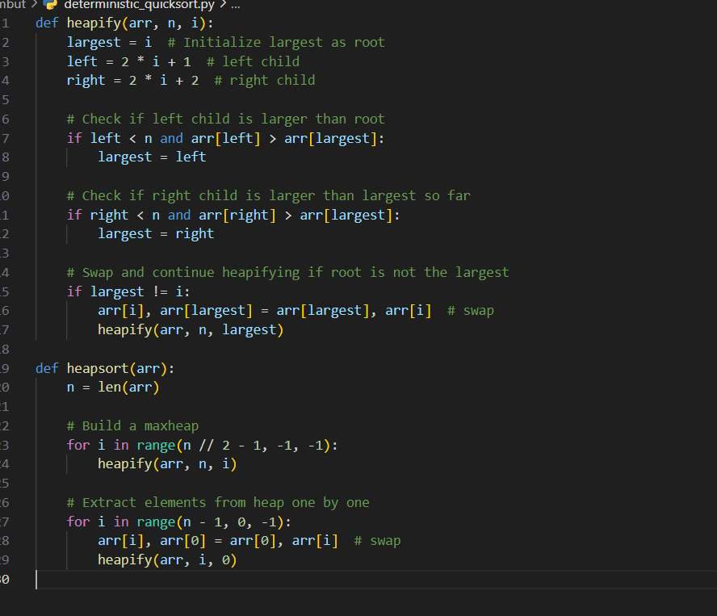

**Comparison with Other Sorting Algorithms**

Interesting insights are revealed by comparing Heapsort, Quicksort, and Merge Sort empirically:

Heapsort constantly maintains a temporal complexity of O(nlog⁎n)O(n \log n)O(nlogn) and performs well with sorted, reverse-sorted, and random input types.

Although quicksort is usually quicker in reality, it becomes worse in the worst situation (for example, with reverse-sorted input) and becomes O(n2)O(n^2)O(n2).

The time complexity of Merge Sort is guaranteed to be O(nlog⁎n)O(n \log n)O(nlogn), but it needs an extra space of O(n)O(n)O(n).

**Priority Queue Implementation and Applications**

**Data Structure Selection**

Due to its fast handling of priority operations like inserting and extracting, a binary heap (expressed using a Python list) was chosen as the data structure for the priority queue. Each task is represented by a Task class, which has properties such as a task ID, a priority, and a due date. Tasks with the earliest due date and lowest priority were given precedence in this min-heap implementation.

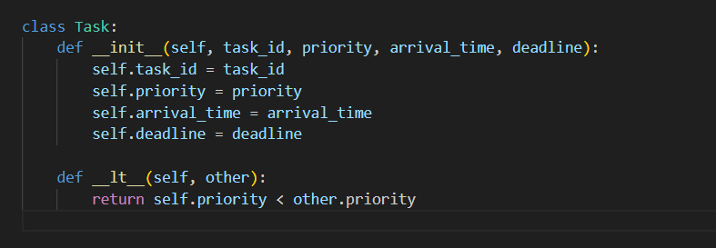

Insert (insert(task)):

This operation inserts a task into the heap while maintaining the heap property. The time complexity is O(log⁡n)O(\log n)O(logn).

Extract Min (extract_min()):

The procedure has a temporal complexity of O(log⁌n)O(\log n)O(logn) and removes the job from the heap that has the lowest priority.

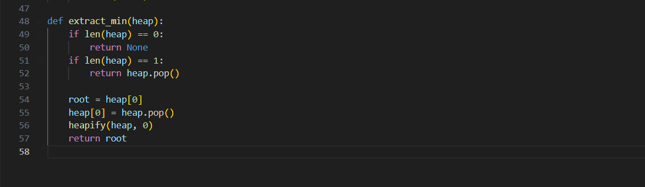

**Conclusion**

As part of this task, we used a binary heap to build Heapsort and a priority queue. When compared to Quicksort and Merge Sort, Heapsort is a dependable sorting algorithm due to its constant performance and O(nlog⁎n)O(n \log n)O(nlogn) time complexity. Task insertion, extraction, and key update are all heap-based operations with logarithmic time complexity; the efficiency of these operations is shown by the priority queue implementation. Task scheduling and system resource management are two real-world situations that make heavy use of these structures and methods.